**ACKNOWLEDGEMENT**

I extend our sincere and heartfelt thanks to our esteemed guide, Prof. P. D. Boraste and for his exemplary guidance, monitoring and constant encouragement throughout the semester at crucial junctures and for showing us the right way.

I am grateful to respected coordinator Prof. P. D. Boraste for permitting me to utilize all the necessary facilities of the Institute.

I would like to extend thanks to our respected Head of the department Prof. P. D. Boraste for allowing us to use the facilities available.

**ABSTRACT**

This report scrutinizes the use of different concepts of applets in GUI application Development Using VB.net enabling viewer to get the complete concept of different aspects of Visual Basic .NET. Visual Basic, originally called Visual Basic .NET, is a multi-paradigm, object-oriented programming language, implemented on .NET, Mono, and the .NET Framework. To satisfy this we created a simple program for Hotel Management System.

**INDEX**

|  |  |  |
| --- | --- | --- |
| **Sr. No.** | **Contents** | **Page No.** |
| 1. | Introduction | 3 |
| 2. | Code | 6 |
| 3. | Result | 10 |
| 4. | Conclusion | 14 |
| 5. | Reference | 15 |

**Chapter-1**

**INTRODUCTION**

**Visual Basic .NET:**

Visual Basic, originally called Visual Basic .NET (VB.NET), is a multi-paradigm, object-oriented programming language, implemented on .NET, Mono, and the .NET Framework. Microsoft launched VB.NET in 2002 as the successor to its original Visual Basic language, the last version of which was Visual Basic 6.0. Although the ".NET" portion of the name was dropped in 2005, this article uses "Visual Basic [.NET]" to refer to all Visual Basic languages released since 2002, in order to distinguish between them and the classic Visual Basic. Along with C# and F#, it is one of the three main languages targeting the .NET ecosystem. As of March 11th, 2020, Microsoft announced that evolution of the VB.NET language has concluded.

Microsoft's integrated development environment (IDE) for developing in Visual Basic is Visual Studio. Most Visual Studio editions are commercial; the only exceptions are Visual Studio Express and Visual Studio Community, which are freeware. In addition, the .NET Framework SDK includes a freeware command-line compiler called vbc.exe. Mono also includes a command-line VB.NET compiler.



Fig. 1. VB.NET

**Graphical user interface (GUI):**

The graphical user interface (GUI) is a form of user interface that allows users to interact with electronic devices through graphical icons and audio indicator such as primary notation, instead of text-based user interfaces, typed command labels or text navigation. GUIs were introduced in reaction to the perceived steep learning curve of command-line interfaces (CLIs), which require commands to be typed on a computer keyboard.

The actions in a GUI are usually performed through direct manipulation of the graphical elements. Beyond computers, GUIs are used in many handheld mobile devices such as MP3 players, portable media players, gaming devices, smartphones and smaller household, office and industrial controls. The term GUI tends not to be applied to other lower-display resolution types of interfaces, such as video games (where head-up display (HUD) is preferred), or not including flat screens, like volumetric displays because the term is restricted to the scope of two-dimensional display screens able to describe generic information, in the tradition of the computer science research at the Xerox Palo Alto Research Center.

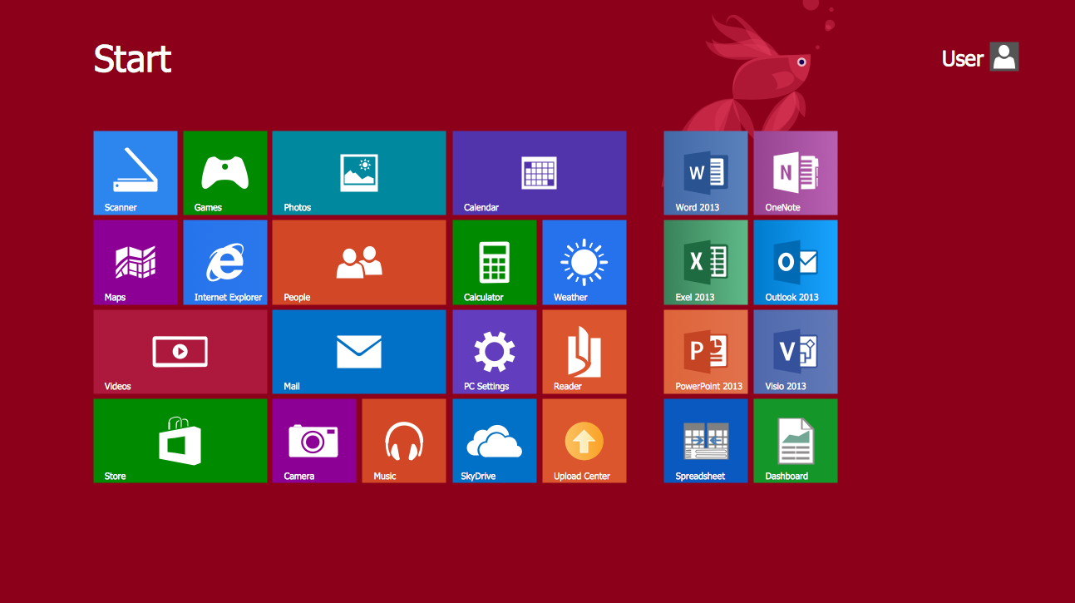

Fig. 2. Windows 8 GUI

**Hotel Management System:**

A nailed down definition of hotel management is that it’s ‘a field of business and a study, that tends itself to the operational aspects of a hotel as well as a wide range of affiliated topics. Such as: Accounting, administration, finance, information systems, human resource management, public relations, strategy, marketing, revenue management, sales, change management, leadership, gastronomy and more.’Clearly there’s a lot to be aware of and many of these functions do require specialists. However not all properties have the luxury of hiring a full team of staff, so it’s certainly not impossible to run a successful small hotel business without a range of degrees. By driving prices up during high peak periods and knowing how much to discount prices by to ensure rooms are rented during low peak periods, hotels can maximise their return. Through dynamic pricing, businesses can provide discounts and incentives in a controlled way during different seasons.

Hotels generally advertise their rooms through multiple channels, such as online travel agencies, to optimise reach and promote sales. Distribution management is essential and this involves calculating the minimum numbers of rooms needing to be sold for any given period by each channel. In doing so, you then have the ability to make informed choices regarding reallocation from cancellations or where to list spare rooms to maximise sales. Being aware of your market and the variable preferences, demands and affordability of different demographics are paramount to understanding how to price and distribute your room sales across the various channels.

Not only does this help in managing your existing rooms, but it can also allow you to capture more of the market and increase sales and revenue. Flexibility is an important virtue required of hoteliers and being able to understand your clientele and adapt to their needs is vital to building loyalty and guaranteeing profitability.

**Chapter-2**

**CODE**

**‘login .vb**

Public Class Login

Private Sub Label1_Click(sender As Object, e As EventArgs) Handles Label1.Click

Label1.TextAlign = ContentAlignment.MiddleCenter

End Sub

Private Sub Button1_Click(sender As Object, e As EventArgs) Handles Button1.Click

If TextBox1.Text = "Omkar" And

TextBox2.Text = "OMKAR123" Then

MsgBox("Welcome to Nourriture pour le plasir", MsgBoxStyle.ApplicationModal, "Nourriture pour le plasir")

Main.Show()

Visible = False

Else

MsgBox("Wrong Username or Password!", MsgBoxStyle.Exclamation, "Nourriture pour le plasir")

End If

End Sub

Private Sub Button2_Click(sender As Object, e As EventArgs) Handles Button2.Click

End

End Sub

Private Sub Login_Load(sender As Object, e As EventArgs) Handles MyBase.Load

End Sub

End Class

**‘ Main.vb**

Public Class Main

Private Sub Main_Load(sender As Object, e As EventArgs) Handles MyBase.Load

IsMdiContainer = True

Me.Text = "Welcome"

End Sub

Private Sub RoomToolStripMenuItem_Click(sender As Object, e As EventArgs) Handles RoomToolStripMenuItem.Click

Dim fm2 As New BookRoom

fm2.MdiParent = Me

fm2.Show()

End Sub

Private Sub OtherServicesToolStripMenuItem1_Click(sender As Object, e As EventArgs) Handles OtherServicesToolStripMenuItem1.Click

Dim fm3 As New RoomStatus

fm3.MdiParent = Me

fm3.Show()

End Sub

Private Sub CancelRoomToolStripMenuItem1_Click(sender As Object, e As EventArgs) Handles CancelRoomToolStripMenuItem1.Click

Dim fm4 As New OtherServices

fm4.MdiParent = Me

fm4.Show()

End Sub

Private Sub ContactUsToolStripMenuItem1_Click(sender As Object, e As EventArgs) Handles ContactUsToolStripMenuItem1.Click

Dim fm5 As New DeleteRoom

fm5.MdiParent = Me

fm5.Show()

End Sub

Private Sub ContactUsToolStripMenuItem_Click(sender As Object, e As EventArgs) Handles ContactUsToolStripMenuItem.Click

Dim fm6 As New ContactUs

fm6.MdiParent = Me

fm6.Show()

End Sub

End Class

**‘bookroom.vb**

Public Class BookRoom

Private Sub Button2_Click(sender As Object, e As EventArgs) Handles Button2.Click

Close()

End Sub

Private Sub Save_Click(sender As Object, e As EventArgs) Handles Save.Click

If CheckBox1.Checked = True Then

MsgBox("Data Saved!, your Room ID is 69", MsgBoxStyle.Information, "Nourriture pour le plasir")

Close()

Else

MsgBox("Please Check the Agree Terms and Condition Box", MsgBoxStyle.Information, "Nourriture pour le plasir")

End If

End Sub

End Class

**‘deleteroom.vb**

Public Class DeleteRoom

Private Sub Button1_Click(sender As Object, e As EventArgs) Handles Button1.Click

MsgBox("Your Room has been successfully Canceled", MsgBoxStyle.Information, " Nourriture pour le plaisir")

Visible = False

End Sub

End Class

**‘roomstatus.vb**

Public Class RoomStatus

Private Sub Roomstatus_Load(sender As Object, e As EventArgs) Handles MyBase.Load

End Sub

Private Sub Label3_Click(sender As Object, e As EventArgs) Handles Label3.Click

End Sub

End Class

**‘otherservice.vb**

Public Class OtherServices

Private Sub OtherServices_Load(sender As Object, e As EventArgs) Handles MyBase.Load

End Sub

Private Sub Button1_Click(sender As Object, e As EventArgs) Handles Button1.Click

MsgBox("Data Saved", MsgBoxStyle.Information, "Nourriture pour le plasir")

Visible = False

End Sub

Private Sub Button2_Click(sender As Object, e As EventArgs) Handles Button2.Click

Close()

End Sub

End Class

**‘contactus.vb**

Public Class ContactUs

Private Sub Button1_Click(sender As Object, e As EventArgs) Handles Button1.Click

MsgBox("Sent!", MsgBoxStyle.Information, " Nourriture pour le plaisir")

Visible = False

End Sub

End Class

**Chapter-3**

**RESULT**

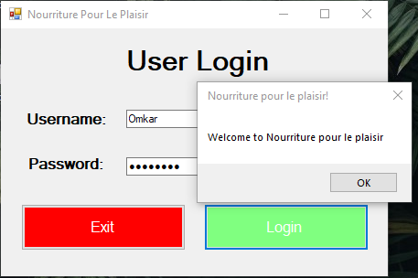

Fig. 3. Login Page

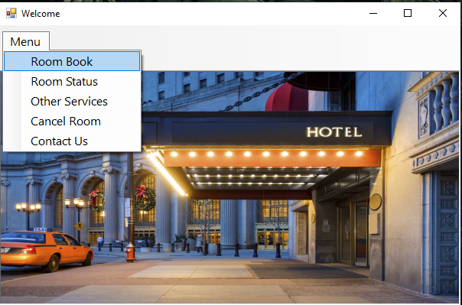

Fig. 4. Menu

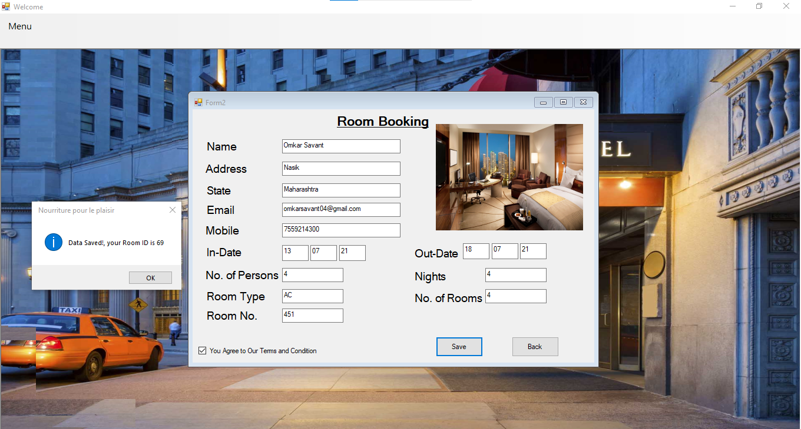

Fig. 5. Book Room

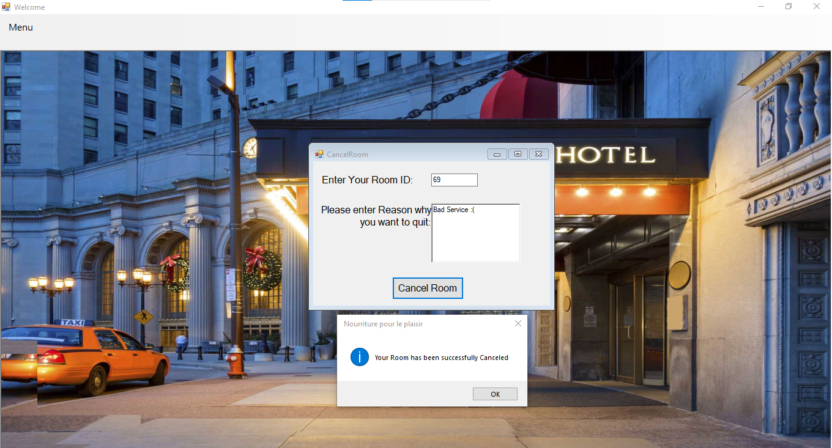

Fig. 6. Cancel Room

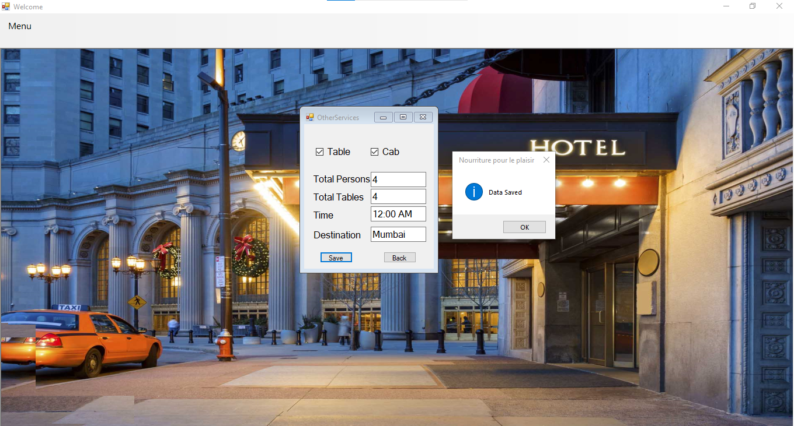

Fig. 7. Other Services

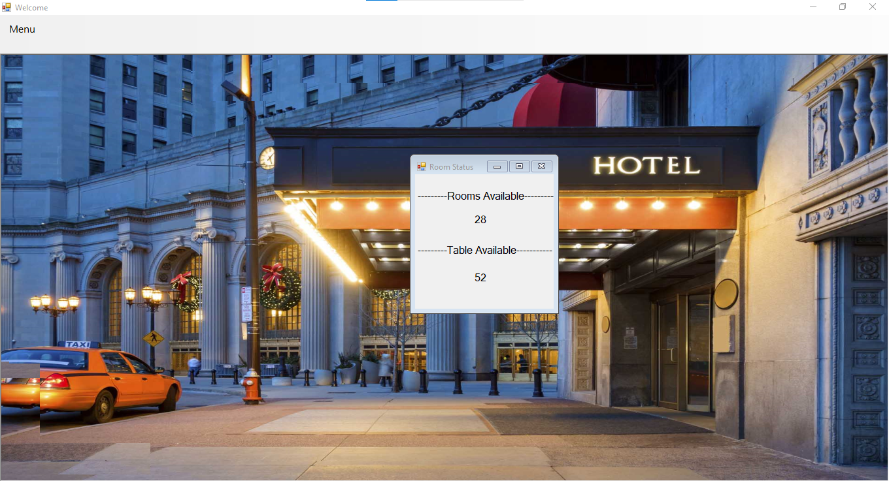

Fig. 8. Room Status

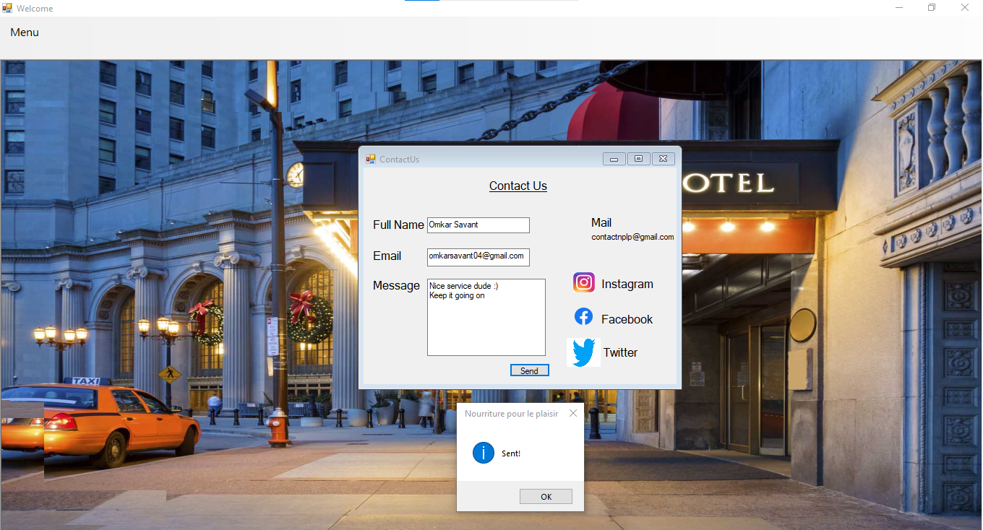

Fig. 9. Contact Us

**CONCLUSION**

Visual Basic is often used in conjunction with the Windows Forms GUI library to make desktop apps for Windows. Programming for Windows Forms with Visual Basic involves dragging and dropping controls on a form using a GUI designer and writing corresponding code for each control. Designing the visual composition and temporal behavior of a GUI is an important part of software application programming in the area of human–computer interaction.

Its goal is to enhance the efficiency and ease of use for the underlying logical design of a stored program, a design discipline named usability. Methods of user-centered design are used to ensure that the visual language introduced in the design is well-tailored to the tasks.

The official Visual Basic compiler is written in Visual Basic and is available on GitHub as a part of the .NET Compiler Platform. The creation of open-source tools for Visual Basic development has been slow compared to C#, although the Mono development platform provides an implementation of Visual Basic-specific libraries and a Visual Basic 2005 compatible compiler written in Visual Basic, as well as standard framework libraries such as Windows Forms GUI library.

SharpDevelop and MonoDevelop are open-source alternative IDEs. The Gambas environment is also similar but distinct from Visual Basic.

A GUI may be designed for the requirements of a vertical market as application-specific graphical user interfaces. Examples include automated teller machines (ATM), point of sale (POS) touchscreens at restaurants, self-service checkouts used in a retail store, airline self-ticket and check-in, information kiosks in a public space, like a train station or a museum, and monitors or control screens in an embedded industrial application which employ a real-time operating system (RTOS).

**REFERENCES**

1. <https://en.wikipedia.org/wiki/Visual_Basic_.NET>
2. <https://en.wikipedia.org/wiki/Graphical_user_interface>
3. <https://www.siteminder.com/r/trends-advice/hotel-management/hotel-management-definitions-operations-ideas-software/>